Axiom Requisition Copy Service
2869 Jolly Road, Okemos, Michigan 48864
517.886.5099 – 877.886.5090 toll free – 517.886.4116 facsimile

AUTHORIZATION FOR RELEASE OF DOCUMENTS CONTAINING HEALTH INFORMATION

TO: University of Michigan Hospital and Health Center Release of Information Unit
Dept. Release of Information Unit - NCAC
2901 Hubbard Street Room 2722
Ann Arbor, MI 48109-0000

1. | Batman |  | xxx-xx-5555 |  | 01/01/1979
 | PATIENT’S NAME |  | SOCIAL SECURITY NUMBER |  | DATE OF BIRTH
REGARDING:
2. I, the undersigned, hereby authorize the records custodian or the medical records department or the director or designee of the above named (the “Releasing Party”) to release or disclose documents containing health information to Axiom Requisition Copy Service, an agent of Smith and Jones PC (the “Receiving Party”).
3. This authorization is made in accordance with the federal and state law and is valid for a period of 12 months after being signed or at the conclusion of the legal action of , whichever is later or as follows:____________
4. I understand that I may revoke this authorization at any time by sending a written revocation to University of Michigan Hospital and Health Center Release of Information Unit, except to the extent that it has taken action in reliance on the authorization.
5. I understand that once my health information is used or disclosed pursuant to this authorization, it may be subject to re-disclosure or release by the Receiving Party and may no longer be protected by federal or state law.
6. A description of the health information I authorize for use or disclosure is: FROM 01/01/1979 TO PRESENT: Any and all MEDICAL RECORDS, including but not limited to patient history form(s), reports, etc. pertaining to Batman SSN: xxx-xx-5555, DOB: 01/01/1979. All protected health information regarding the individual in your custody which may include information relating to acquired immunodeficiency syndrome (AIDS), or human immunodeficiency virus (HIV), information about behavioral or mental health services, and treatment for alcohol and drug abuse. This request may also include any information regarding communicable diseases and serious communicable diseases and infections, which includes venereal disease, tuberculosis, or ARC, if any, as well as all Genetic Information and Demographic Information for the purposes and Conditions designated on this Form. Such information will be oral and in writing, and should include all notes, consultations, orders, medications, prescriptions, operative reports, pathology reports, pathology slides, x-ray reports, x-rays, graphic records, nurses notes, subjective symptoms, opinions, diagnoses, prognoses, contributing factors, complications, reports, correspondence, photographs, medical records, and any other medical information you may have.

7. This authorization for release of my documents containing health information is provided in connection with the legal action referred to above in which allegations of wrongful conduct, damage or loss have been made making the above information discoverable under state law.
8. This authorization is voluntary. I understand that my continued or future treatment by or payment to the Releasing Party, enrollment, or eligibility for benefits is not conditioned upon my providing or signing this authorization.

9. A photocopy of this consent is as valid as the original.

10. I have been provided with a copy of this authorization for my records. _________. (initials)

______________________________________________________________________ _____________________________________
PATIENT SIGNATURE DATE

______________________________________________________________________ _____________________________________
PARENT / LEGAL GUARDIAN SIGNATURE RELATIONSHIP DATE

______________________________________________________________________ _____________________________________
PERSONAL REPRESENTATIVE (DECEASED PATIENT) DATE
(PLEASE INCLUDE LETTER OF AUTHORITY TO ACT FOR THIS INDIVIDUAL)

SUBSCRIBED AND SWORN BEFORE ME

THIS _____________DAY OF ______________________________, 20 ________

____________________________________________________________________

NOTARY PUBLIC __________________________________________COUNTY

MY COMMISSION EXPIRES: ________________________________________

Order No. 01-29018 - 002
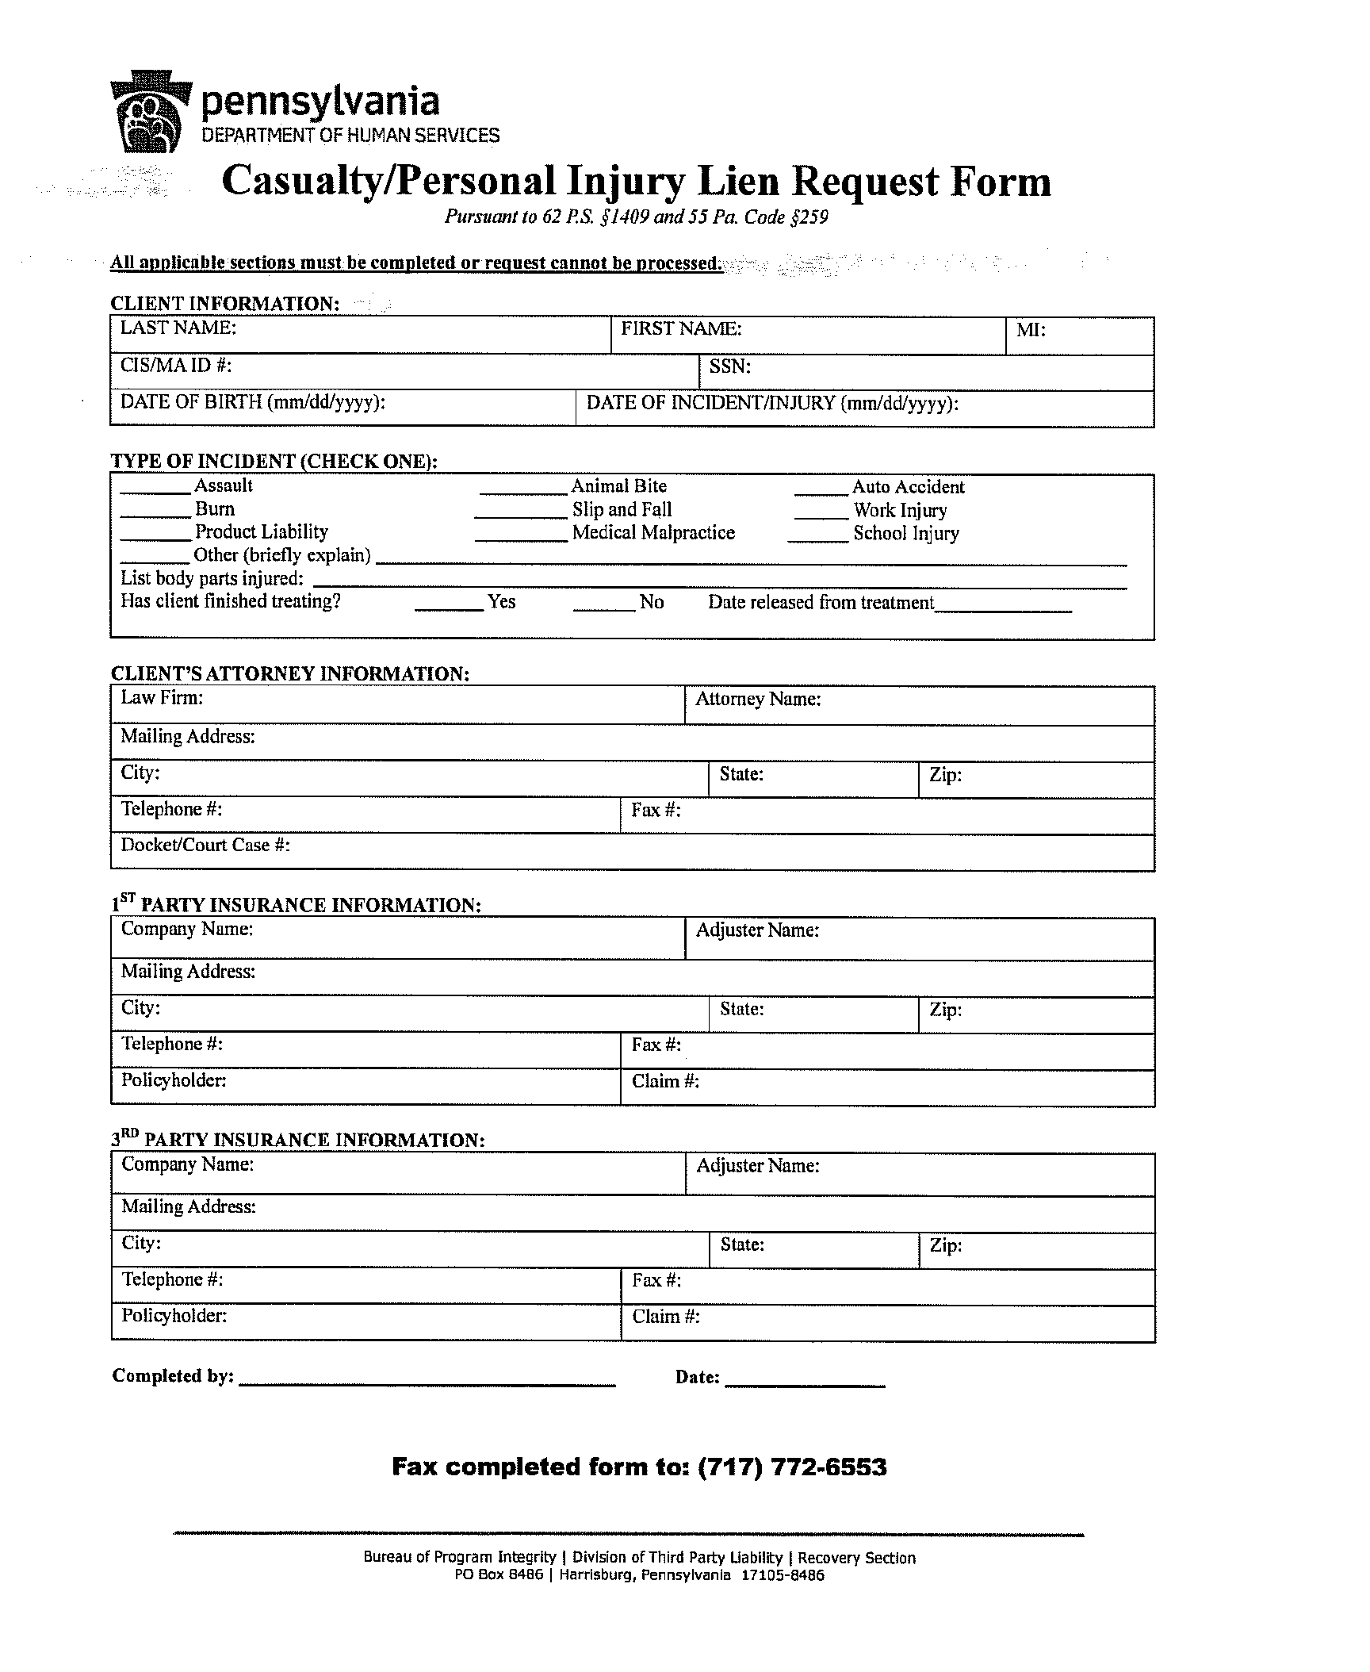
Batman
xxx-xx-5555
01/01/1979

